Question 2

1)pulled ubuntu image

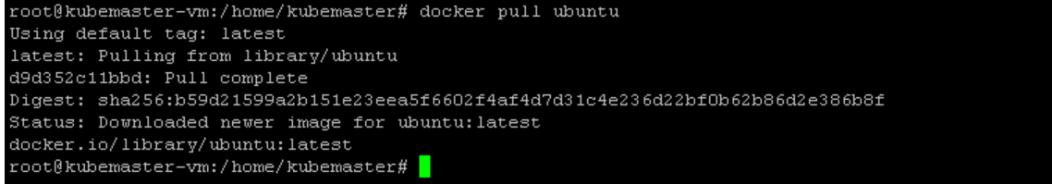



2)running the container



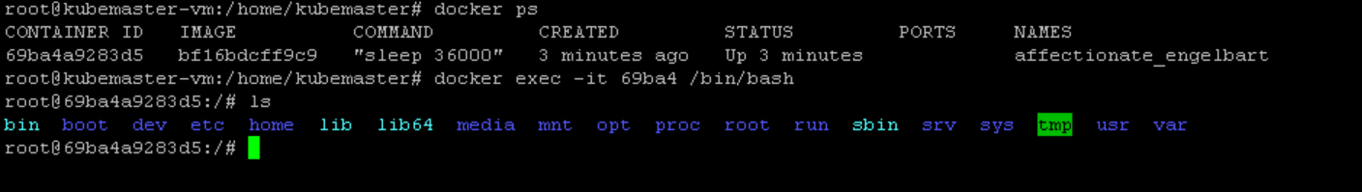

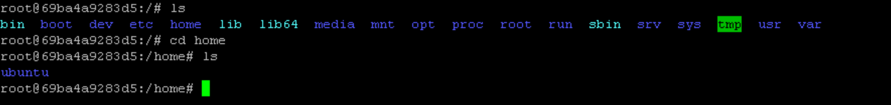

3)verification of container system resources

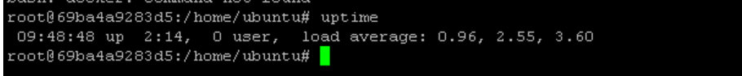

4)stopping and cleaning up



